

PROJECT REPORT TEMPLATE



INTRODUCTION



Overview

An Event Management System provides campus event planners a flexible, fully integrated solution to simplify the event management process and keep your customers, faculty and students happy, while maintaining important reports and data for making real estate and future planning decisions.

An event management system allows you to:

Minimize administration efforts

Eliminate missed communications

Digitize how your events are run

Comply with COVID-19 safety guidelines

Maximize your campus flexibility

Save time planning future events

Access detailed reports & analytics

Purpose

An Event Management System (or Event Management Software) helps organizers plan, execute and report on events, driving success for their business.

Communication is the leading cause of event failures or mishaps. An event management system facilitates instant communication between planners and providers and makes it easier to share timely information to students, faculty, catering, operations, and more

The world continues to move toward a digital-first mind set. By bringing your campus into the digital age with a mobile, agile event solution, you ensure that the platform scales with you and provides multiple digital, accessible touch points for users

Problem Definition and Design Thinking



Empathy Map

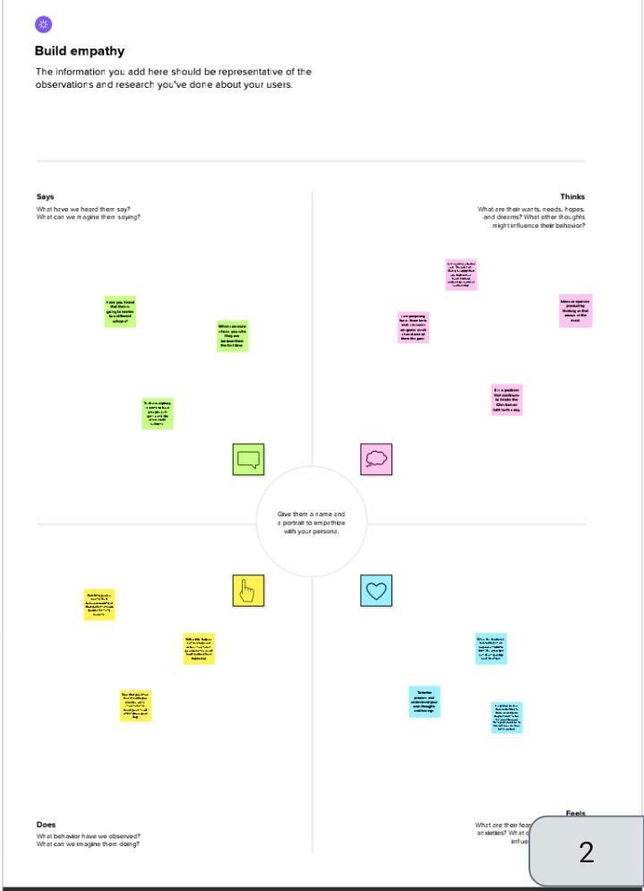

Ideation and Brainstorming map Screenshot:

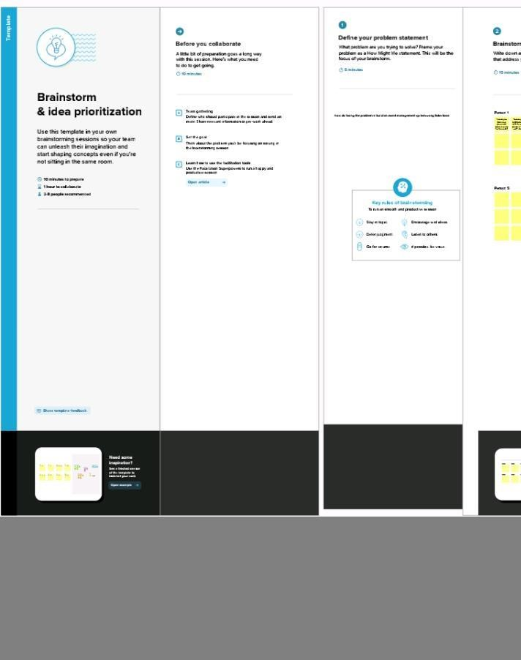

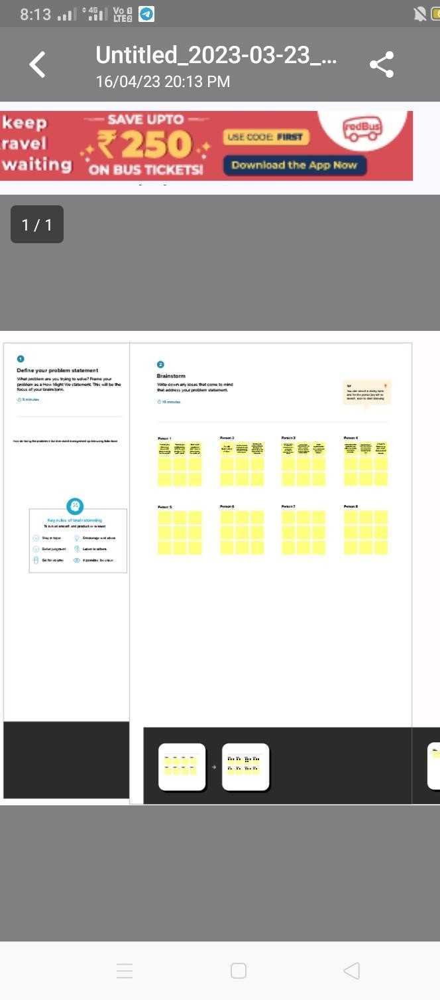

Result:

Data Model:



Field label: status

Data type: pick list

Field label: close Date

Data type: Date

Field label: mobile phone

Data type: phone



Activity and Screenshot:



Create

Salesforce Org

-

creating Developer Accou

nt

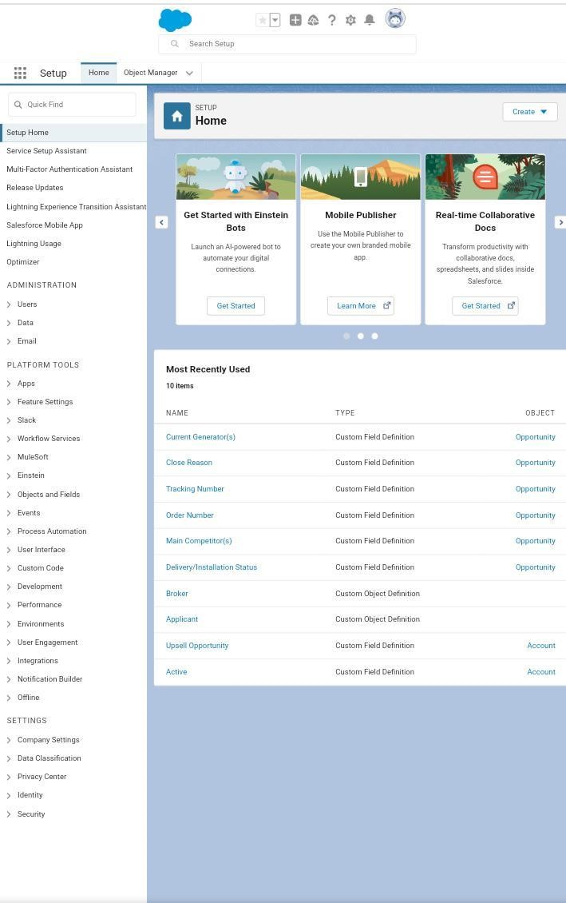

Activity:

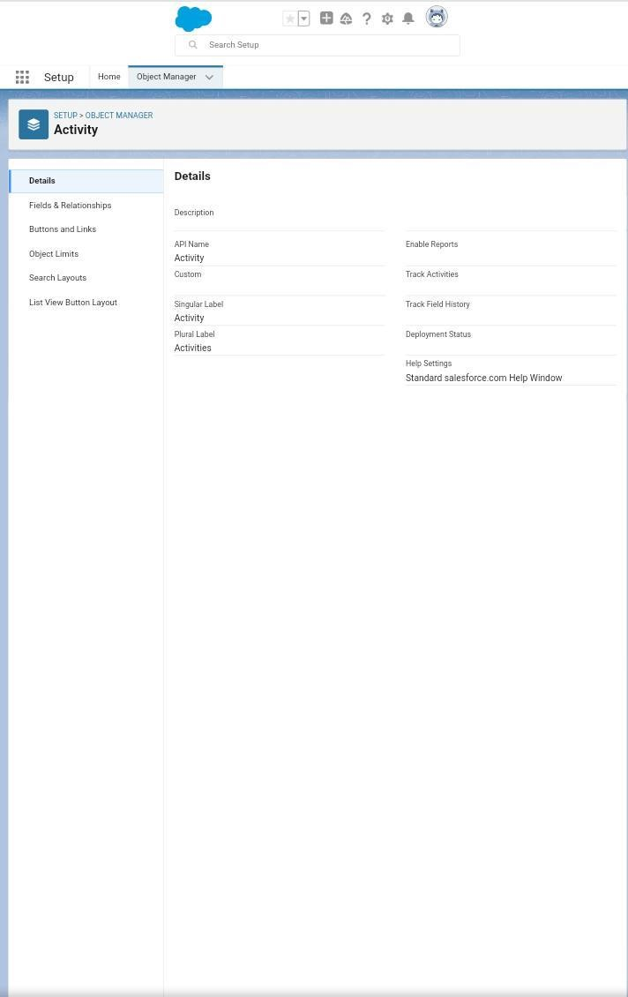

Quarterly Performance

:

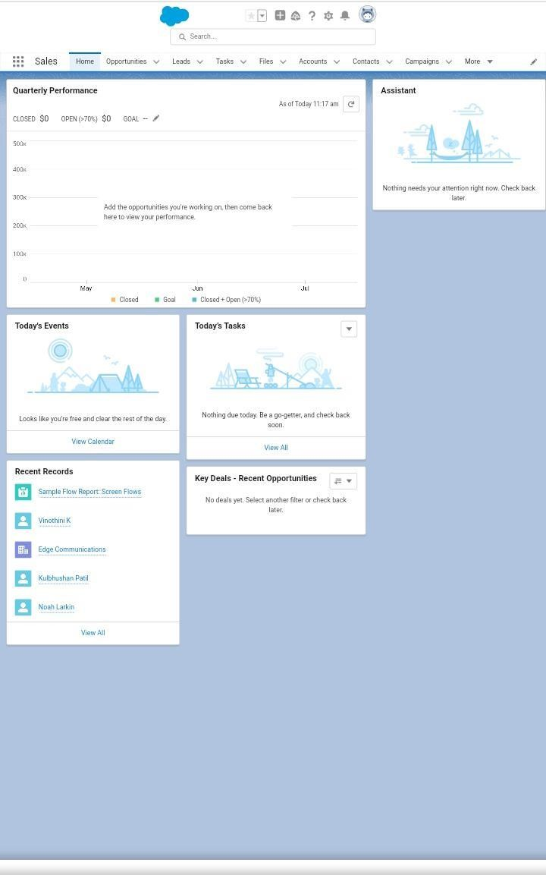

A

pplicant:

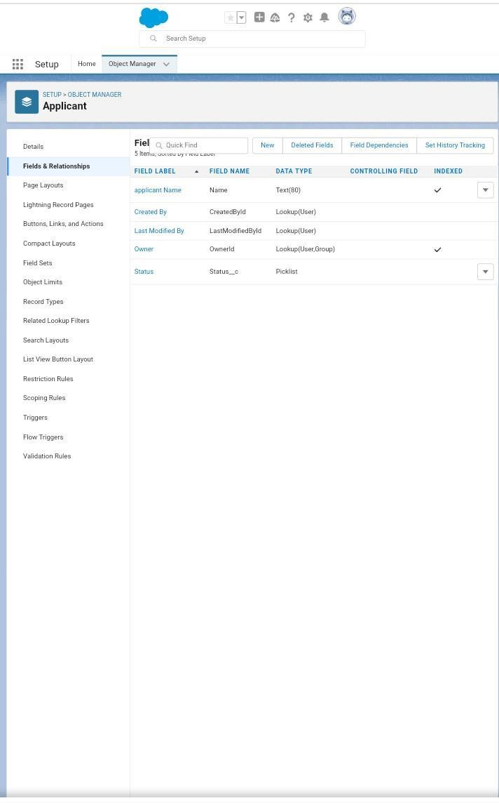

Opportunity:

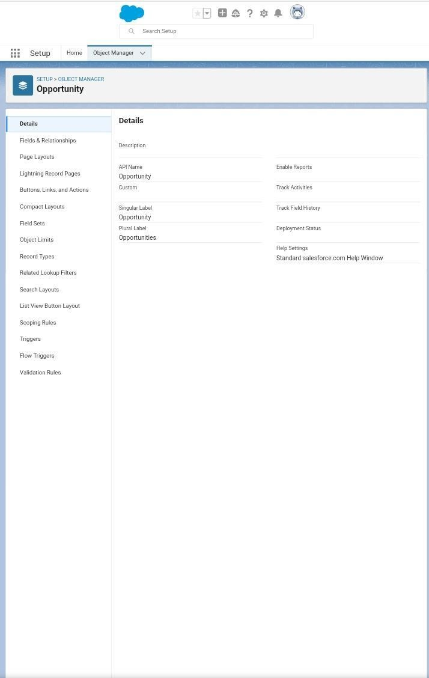

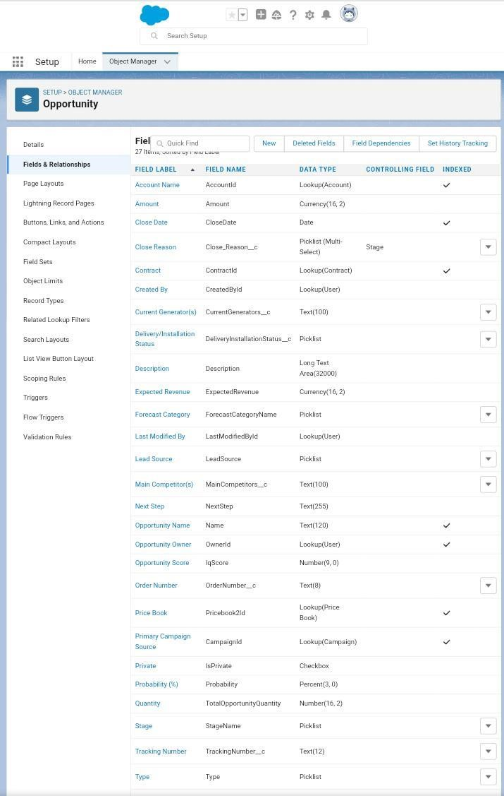



Broker:

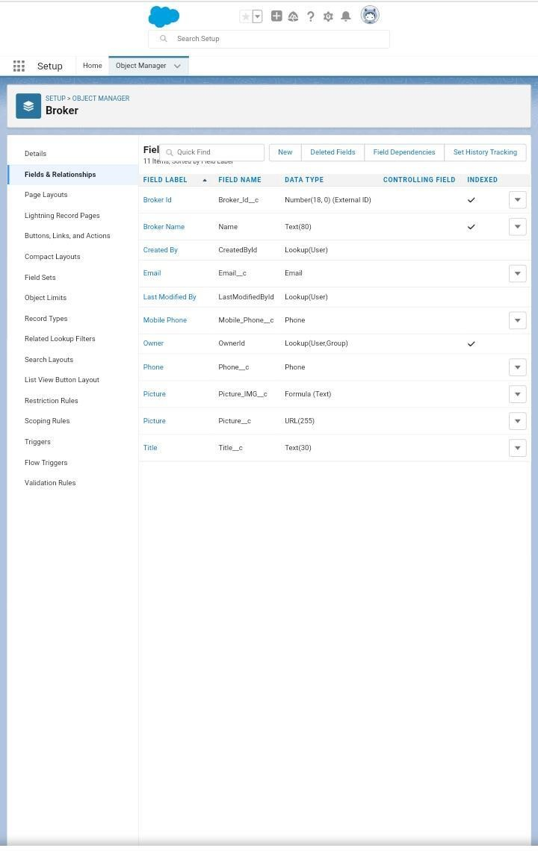

Profile:

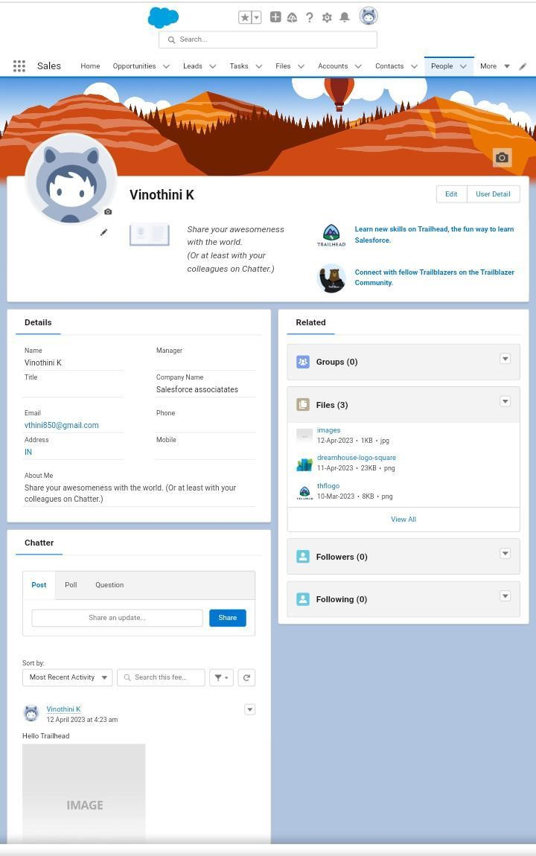

Users:

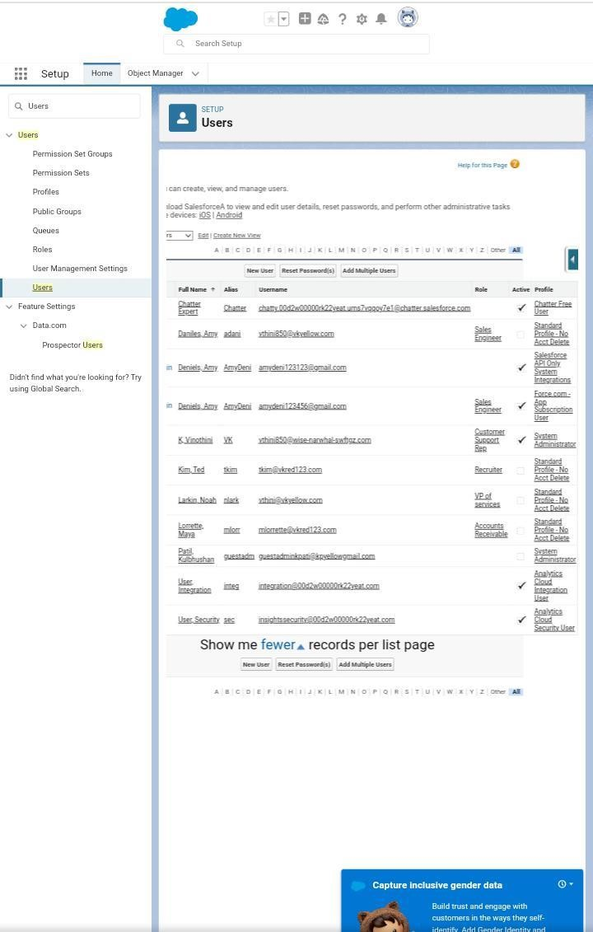

Permission sets:

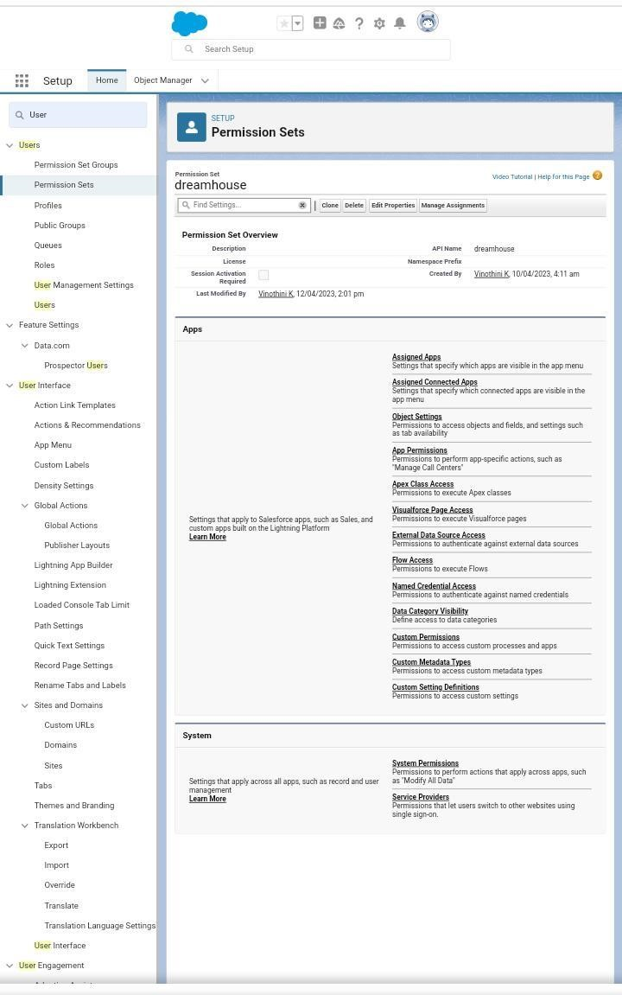

Rep

orts

:

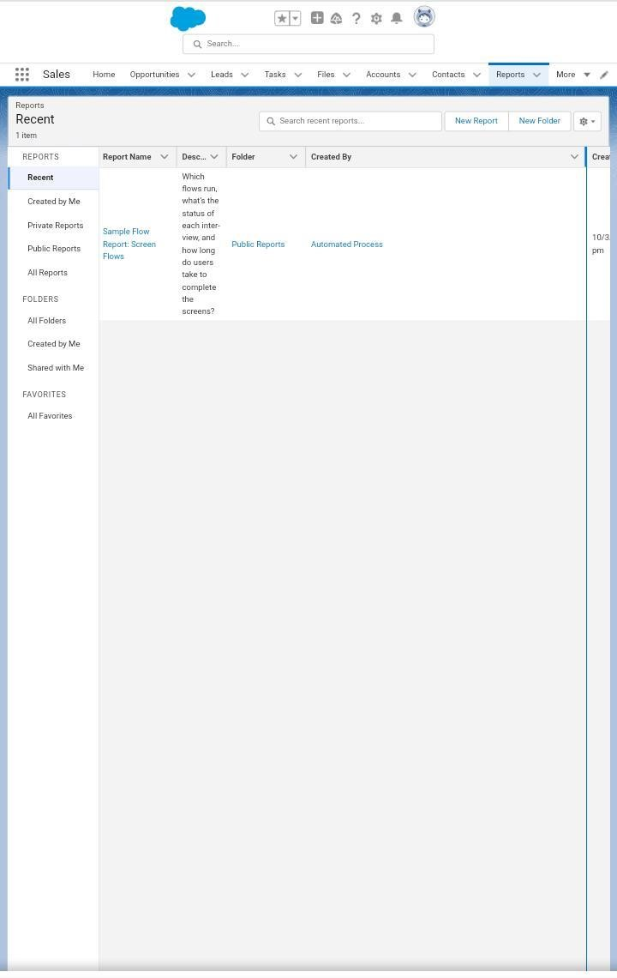

Trailhead Profile Public

Team leader- https://trailblazer.me/id/sswetha63

Team member 1- https://trailblazer.me/id/swathy

Team member 2- https://trailblazer.me/id/swetha

Team member 3- https://trailblazer.me/id/sujatha

Advantages & Disadvantages:

The advantages of being an event manager can include:



1. Opportunities for creativity

As an event manager, you can use your creative skills and talents to coordinate the details of parties and celebrations. Your client base might prefer different party styles, allowing you to take creative approaches to each event. This might include determining the colour scheme and decorations for an event. The daily routine of an event manager often changes and requires a unique and creative set of skills for these professionals to adapt.

1. Ability to work on different events

An event manager often works on several types of events. For example, they might plan a business conference, holiday party, music festival or product launch. Because of this, an event manager often has an exciting career and interesting responsibilities. You can improve your management abilities with each kind of event you plan by gaining experience in different areas, like managing both corporate events and personal celebrations.

1. Chance to work with diverse clients

Event managers may travel and work with people in different areas to plan their parties and celebrations. You can meet a variety of clients from different backgrounds with unique goals for their events. This allows you to customize your skills and expertise when working with each customer. By working with a diverse group of people, you might improve your communication and social skills and learn new techniques to apply to future clients.

1. Collaborative work environment

Event managers often work on a team to manage and coordinate the details of their events. This can help you learn from other professionals in your field and try new approaches to event management. Collaboration may also make your work environment supportive. For instance, you might coordinate some events yourself or delegate tasks to team members that match their skills, knowledge and experience. Applications:

**Event management** is the application of [project management](https://en.wikipedia.org/wiki/Project_management) to the creation and development of small and/or large-scale personal or corporate events such as [festivals,](https://en.wikipedia.org/wiki/Festival) conferences, ceremonies, weddings, formal parties, concerts, or [conventions.](https://en.wikipedia.org/wiki/Convention_(meeting)) It involves studying the brand, identifying its [target audience,](https://en.wikipedia.org/wiki/Target_audience) devising the event concept, and coordinating the technical aspects before actually launching the event.

The events industry now includes events of all sizes from the [Olympics](https://en.wikipedia.org/wiki/Olympics) down to business breakfast meetings. Many industries, celebrities, [charitable organizations,](https://en.wikipedia.org/wiki/Charitable_organization) and interest groups hold events in order to market their label, build business relationships, raise money, or celebrate achievement.

The process of planning and coordinating the event is usually referred to as **event planning** and which can include [budgeting,](https://en.wikipedia.org/wiki/Budget) scheduling, site selection, acquiring necessary [permits,](https://en.wikipedia.org/wiki/License) coordinating transportation and parking, arranging for speakers or entertainers, arranging decor, event security, [catering,](https://en.wikipedia.org/wiki/Catering) coordinating with third-party vendors, and emergency plans. Each event is different in its nature so process of planning and execution of each event differs on basis of the type of event.

The **event manager** is the person who plans and executes the event, taking responsibility for the creative, technical, and logistical elements. This includes overall event design, brand building, marketing and communication strategy, [audio-visual p](https://en.wikipedia.org/wiki/Audio-visual)roduction, script writing, logistics, budgeting, negotiation, and client service.

Due to the complexities involved, the extensive body of knowledge required, and the rapidly changing environment, event management is frequently cited as one of the most stressful career paths, in line next to [surgeons.](https://en.wikipedia.org/wiki/Surgeon)

Conclusion:

Event Management System is user friendly and cost effective system, it is customized with activities related to event management life-cycle. It provides a new edge to management industry. Solution Dot always keep your objectives and goals on top priority while developing any plan of work.

Future Scope:

The scope of event management as a career in India is immense. This career provides a unique opportunity to rephrase our social beliefs. Hosting events can redesign the structure of a city by facilitating economic growth, employment opportunities, urban development, and promoting indigenous culture and heritage.